

System Devices
Interface Control Document
ICD.FASIT.SYS
Release 2.1

25 May 2007



Approved for public release; distribution is unlimited
Release 2.1
25 May 2007

PREPARATION:
Prepared By: | SIGNED  _________________________ | Date: | 8 June 2007  _______________
James Todd
Lead Systems Engineer
LT2 - FASIT
Coordinated with: | SIGNED  _________________________ | Date: | 8 June 2007  _______________
Randi Kahl
Project Director
LT2 - FASIT
REVIEWED:
Endorsed by: | SIGNED  _________________________ | Date: | 8 June 2007  _______________
Paul Dumanoir
Chief Engineer, LT2
PM TRADE
Endorsed by: | SIGNED  _________________________ | Date: | 12 June 2007  _______________
Phil Gaylardo
Dep Dir Acq Log
PM TRADE
Endorsed by: | SIGNED  _________________________ | Date: | 12 June 2007  _______________
Robert Parrish
Dep Dir EL
APPROVED
Approved by: | SIGNED  _________________________ | Date: | 15 June 2007  _______________
Jorge Rivera
APM LT2

List of Revisions
Revision Log
Revision/Version No. | Description | Date
Release 1.0  Release 2.0  Release 2.1 | Initial Release  This is the initial release of this ICD since NGATS responsibility was moved within PEO STRI from PM ITTS to PM TRADE. It is the first of a new set of ICDs based on the concept of a Common Interface Component. The set now includes this System ICD, containing information common to all device types, and a series of ICDs with the messages and fault codes unique to each device type.  Changes from the previous PM-ITTS ICD include:  Incorporated comments from the October 2005 Targetry WG meeting.  Incorporated comments from industry.  Changed project named from New Generation Army Targetry Systems (NGATS) to Future Army System of Integrated Targets (FASIT) and updated all tables and diagrams accordingly  Removed “For Official Use Only” designation as this cannot be justified under Army Policy and Freedom of Information Act exemptions.  Expanded the Acronyms and Abbreviations to include all terms used in the document.  Changed Target Processor to Target Controller  Deleted the System Architecture (formerly Figure 1) as it is not representative of the likely architectures using the Common Target Controller concept.  Added the device-type ICDs to the List of Reference Documents in Section 2.1.  Changed TMO to PM TRADE as the responsible lead agency for the document.  Added new Figure 1 to show the Target Emplacement Primary Power Receptacles.  Removed wording about who provides cables.  Updated the text in Section 3.1.2 describing the Communication Connections based on the current RTLP and Corps of Engineers range design guidelines.  Added text to 3.1.4.1 indicating IPv4 with upgrade path to IPv6  Added a “Common” Bit Request message (message number 100) as section 3.1.4.3.1  Added Table 1 in Section 3.1.4.2.3 to clarify the variable type designations.  Added “Reserved For Future Use” field to header (to fill space formerly occupied by timestamp)  Clarified ICD version and sequence ID fields  Added sequence diagrams for major functional threads as Figures 14-17  Changed section 4 to show items as “To Be Developed” vice “Not Approved for Dissemination”  Added the document number to the document header.  Changed the name of Message 100 from Common Bit Request to Device Definition Request.  Changed the ICD field in the message header from a Float to two (2) Unsigned Shorts. This has no effect on the overall message length, but provides integers representing the whole number and fractional portions of the ICD release designation.  Added Section 1.3 to clarify the ICD release designation.  Deleted Section 3.1.1.2.3 and included Figure 10 which described the Thermal Device Power Connector. This is unique to the Presentation Device and is included in the device-type ICD for that device.  Added clarification to Section 3.1.2 to define a device jumper cable for use with a device having a non-standard data connector.  Changed the name of the device message responding to the Device Definition Request from Initiated Bit Status to Device ID and Capabilities.  Deleted Section 4.0, Test and Verification. Requirements will be contained in the FASIT Performance Specification.  Added distribution statement in accordance with DoDD 5230.24.  Moved UV ahead of VAC in the Acronyms and Abbreviations List to correct alphabetical order.  Changed BED and WEMD to RED and ESD, respectively, to match current nomenclature. Changes made in the Acronyms and Abbreviations List, Paragraph 3.3.3.1, and Appendix A.  In Paragraph 1.2, corrected “four” sections to “three.”  In Section 2.1, List of Reference Documents:  - Deleted the FASIT Architecture Specification and device ICDs as they are not referenced in the document.  - Added reference to IETF RFC-791, “Internet Protocol,” September 1981.  In Paragraphs 1.0 and 3.1, deleted “FASIT” in front of “Target Controller.” The Target Controller is not a FASIT device.  In connector callouts, changed “or equivalent” to “or commercial equivalent” to clarify that connectors may be commercial grade and do not have to be MS-connectors.  Restructured Section 3.0 to more clearly delineate Power, Communication, and Communication Structure Information.  Corrected the Secondary Power description to define it as the 12VDC input to be used if installation AC power is not available.  Added DHCP Server to the system block in Figure 13.  Clarified two-way communication at the application layer and full duplex at the session layer in Paragraph 3.3.1, per the referenced documents.  Added clarifications to the “Order of Precedence” to ensure APM TRADE vice PM TRADE day-to-day management of the document; and clarification of the ability to document exceptions within the individual devices ICDs to the System ICD requirements.  Added paragraph 2.3 to ensure the applicability of the FASIT ICD is limited to FASIT applications, and is not intended to address other “non-FASIT” applications and interface for those devices utilized in other systems.  Modified routing/approval page. | 4-12-06  5-16-06  4-4-07

Table of Contents
1.0 Scope 1
1.1 System Description 1
1.2 Document Overview 1
1.3 ICD Configuration Control 2
2.0 Related Documents 3
2.1 General 3
2.2 Order of Precedence 3
2.3 Interface Limitation. 3
3.0 Interface Description 4
3.1 Power 4
3.1.1 Target Emplacement Power 4
3.1.2 Device Primary Power 5
3.1.2.1 Device Primary Power Connectors 6
3.1.2.2 Primary Power Cabling 6
3.1.3 Device Secondary Power 8
3.1.3.1 Device Secondary Power Connector 8
3.1.3.2 Secondary Power Cabling 8
3.2 Communication 8
3.2.1 Target Emplacement Communication Connector 8
3.2.2 Device Communication Connector 9
3.2.3 Communication Cabling 10
3.3 Communication Electrical Characteristics 10
3.3.1 Network Structure and Message Protocol 10
3.3.2 Representation of Data 11
3.3.2.1 Byte Ordering 11
3.3.2.2 Enumerated Type Representation 12
3.3.2.3 Numeric Type Representation 12
3.3.2.4 Bit Fields 13
3.3.3 Target Controller to Device Common Message 13
3.3.4 FASIT Device Messaging Response 14
Appendix A – Glossary of Applicable Terms 17

List of Figures

Figure 1. Target Emplacement Primary Power Receptacles 4
Figure 2. Target Power Receptacle Wiring Diagram 5
Figure 3. Auxiliary Power Receptacle Wiring Diagram 5
Figure 4. Target Presentation Device Primary Power 240 VAC Connector Wiring Diagram 6
Figure 5. Device Primary Power 120 VAC Connector Wiring Diagram 6
Figure 6. 240 VAC Common Power Cable Wiring 7
Figure 7. 120 VAC Common Power Cable Wiring 7
Figure 8. Device Secondary Power +12 VDC Connector Wiring Diagram 8
Figure 9. +12 VDC Common Power Cable Wiring 8
Figure 10. Target Emplacement Communication Connector 9
Figure 11. FASIT Device Communication Connector 9
Figure 12. Target Controller to FASIT Device Communication Cable 10
Figure 13. Device Communication Configuration 11
Figure 14. Byte Transmission Order 12
Figure 15. Device Connection 15
Figure 16. Device Reconnect 16
Figure 17. Device Connection Severed 16
Figure 18. Device Command 16

List of Tables

Table I. Variable Detail 13
Table II. Message Number 100 – Device Definition Request 13
Table III. Message Header 14

Acronyms and Abbreviations

ANSI | American National Standards Institute
AWG | American Wire Gauge
BES | Battlefield Effects Simulator
BIT | Built-In Test
BITE | Built-In Test Equipment
CAT6 | Category 6
Char | Character
CRD | Capstone Requirements Document
CSMA/CD | Carrier Sense Multiple Access with Collision Detection
CTC | Combat Training Center
CTIA | Common Training Instrumentation Architecture
C-BIT | Continuous Built-In Test
DHCP | Dynamic Host Configuration Protocol
DNS | Domain Name Server
DOD | Department of Defense
EIA | Electronic Industries Alliance
ERETS | Enhanced Remoted Target System
ESD | Engagement Scoring Device
FASIT | Future Army System of Integrated Targets
FM | Field Manual
FTX | Field Training Exercise
GND | Ground
I-BIT | Initiated Built-In Test
ICD | Interface Control Document
ID | Identifier
IEEE | Institute of Electrical and Electronics Engineers
IETF | Internet Engineering Task Force
IP | Internet Protocol
LAN | Local Area Network
LFX | Live-Fire Exercise
MAC | Media/Medium Access Control
MSB | Most Significant Byte
NATO | North Atlantic Treaty Organization
NEMA | National Electrical Manufacturers Association
NGATS | New Generation Army Targetry System
NIC | Network Interface Card
OA | Operational Architecture
OCONUS | Outside the Continental United States
OEM | Original Equipment Manufacturer
OPFOR | Opposing Force(s)
PD | Presentation Device
PEO STRI | Program Executive Office Simulation, Training and Instrumentation
PM TRADE | Program Manager Training Devices
POST | Power-On Self Test
RD | Representation Device
RED | Range Effects Device
RFC | Request For Comment
RIM | Range Interface Module
RTLP | Range Training Land Program
RVTM | Requirements Verification Test Matrix
TADSS | Training Aids, Devices, Simulators, and Simulations
TC | Target Controller
TCP | Transmission Control Protocol
TES | Tactical Engagement Simulation
TIA | Telecommunications Industry Association
TPM | Technical Performance Measure
UTP | Unshielded Twisted Pair
UV | Ultraviolet
VAC | Volts Alternating Current
VDC | Volts Direct Current

- Scope

The Future Army System of Integrated Targets (FASIT) System Interface Control Document (ICD) describes the common component and higher level interfaces required for operation and two-way communication between the Target Controller and the FASIT Devices. This ICD specifies physical and electrical characteristics of the interfaces as well as the data types, protocols, and semantics involved in the interactions. This ICD is one of a set of documents that specifies the FASIT component interfaces required to support the FASIT architecture. Message definition and sequencing and fault codes will be in separate ICDs for each type of device in the FASIT architecture.
  - System Description
The Future Army System of Integrated Targets is a set of performance specifications and interface control documents intended to provide a set of standardized targetry components (targets, communications, target control) that support the full scope of live training requirements (skills qualification & collective exercises), including seamless integration with training simulation capabilities. Implementation of the FASIT specifications and ICDs will result in an Army-wide training structure that is more consistent in operational methodology, has more flexibility in terms of component usage, and is less costly in terms of procurement and sustainment.

The design architecture for FASIT consists of processors and devices. Processors are defined as architectural objects with inherent computing, control and sequencing capabilities with requirements to control other architectural objects. Devices are architectural objects, which react to commands and events but do not provide inherent control of other objects within the architecture. The physical system at different ranges will vary but, in general, will consist of a processor controlling multiple devices via the Target Controller. Devices are identified to the Target Controller by Media Access Control (MAC) address resolution.

  - Document Overview
This document is divided into three sections. Section 1.0 provides the scope of the document, definitions of key terms, and a short overview of the document content. Section 2.0 lists standards and other documents that are necessary to support the requirements specified in this ICD. Section 3.0 discusses the common physical, electrical, and general communication interfaces between the Target Controller and the FASIT System Devices. The document also contains a list of acronyms and abbreviations used throughout this document. Appendix A is a glossary of terms used in this document and in the device ICDs.

  - ICD Configuration Control
This ICD, and each of the device-type ICDs, will be configuration controlled via a release designation in the X.Y format, e.g. Release 2.0. A change to the whole number portion of the designation (the X) will indicate a change to the interface message structure which may require a design change or Engineering Change Proposal (ECP). A change to the fractional portion of the designation (the Y) indicates an administrative change, clarification, or other minor change which will not require a corresponding software/firmware change.

There is no requirement for an ICD designation embedded in device software/firmware to change in response to changes to the fractional portion of the ICD release designation.
- Related Documents
  - General
List of Reference Documents
ANSI/TIA/EIA-568-B, “Commercial Building Telecommunications Cabling Standards”, August 2001
IETF RFC-791, “Internet Protocol,” September 1981
IETF RFC-793, “Transmission Control Protocol,” September 1981
IETF RFC-2131, “Dynamic Host Configuration Protocol,” March 1997
IETF Standard 13/IETF RFC-1034/IETF RFC-1035, “Domain Name System,” November 1987
IETF RFC-2136, “Dynamic Updates in the Domain Name System,” April 1997
IEEE Standard 754, “IEEE Standard for Binary Floating-Point Arithmetic,” 12 August 1985
IEEE Standard 802.11-1997, “Wireless LAN Medium Access Control (MAC) and Physical Layer Specifications,” June 1997
IEEE Standard 802.3-2002, “Carrier Sense Multiple Access with Collision Detection (CSMA/CD) Access Method and Physical Layer Specifications,” March 2002
CEHNC 1110-1-23, Army Corps of Engineers Sustainable Range Programs Design Guide, 1 December 2004
  - Order of Precedence
Nothing contained in the FASIT System Interface Control Document shall supersede any applicable laws and/or regulations. Any noted conflict between these requirements and any applicable laws and/or regulations should be brought to the attention of the Program Manager Training Devices (PM TRADE) Assistant Project Manager for Live Training Transformation (APM LT2).

In the event of a conflict between the requirements of the FASIT System ICD and the references cited herein, the text of this document shall take precedence.

In the event of a conflict between the requirements of the FASIT System ICD and the FASIT Device ICDs, the text and requirements of this document shall take precedence. Specific exceptions to the requirements of the FASIT System ICD can be defined within FASIT Device ICDs, though approval shall be obtained by PM TRADE, APM LT2 prior to any implementation, and shall not include generic waivers.

  - Interface Limitation.

The interfaces and requirements defined within the FASIT System Interface Control Document and the FASIT Device Interface Control Documents address only the FASIT (network) based interfaces, and do not address any other interfaces, protocols, or messaging that may be supported by the individual devices. These ICDs are not meant to be system/subsystems ICDs, rather only address the FASIT standards and requirements for these classes of devices.
- Interface Description
This section describes the physical, electrical, and common messaging characteristics of the interfaces that are required for communication between the Target Controller and the various FASIT devices, including pyrotechnic, audio, illumination, smoke, presentation, representation, engagement scoring, range effects, and Range Interface Module devices.
  - Power
Primary power for the FASIT-compliant devices is 120/240 or 120 Volts Alternating Current (VAC) supplied by the installation. In general, the PD and RD will connect to the 120/240 VAC source, while other devices will connect to the 120 VAC Auxiliary Power. Where facility power is unavailable, or in the case of a deployed situation, it is anticipated that 12 Volts Direct Current (VDC) will be used as secondary power. Connectors and connections for these sources are described below.
    - Target Emplacement Power
Primary power for the FASIT devices is supplied through 120/240 VAC and 120 VAC receptacles at the target emplacement, which may be a pit or a location such as a room or roof top. The typical target emplacement provides a single NEMA L14-20R, 120/240 VAC, 20-Amp, twist-lock Target Power Receptacle, and one or two NEMA L5-20R, 120VAC, 20-Amp, twist-lock Auxiliary Power Receptacles.

Figure 1 shows the receptacles and additional information is available in the Corps of Engineers Sustainable Range Programs Design Guide, CEHNC 1110-1-23, dated 1 December 2004. This is available at http://www.hnd.usace.army.mil/rtlp/DesignManuals.aspx.



Figure 1. Target Emplacement Primary Power Receptacles
The Target Power Receptacle is wired in accordance with Figure 2 and the Auxiliary Power Receptacle is wired in accordance with Figure 3.

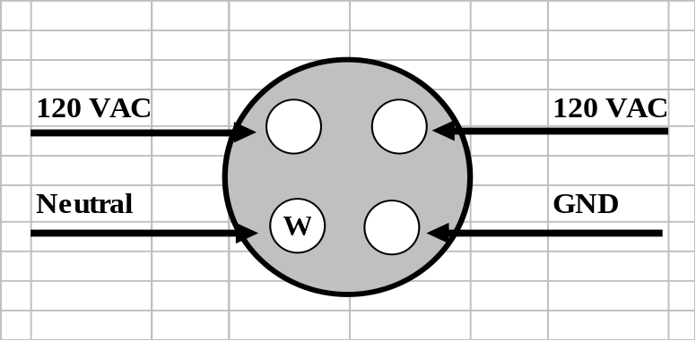

Figure 2. Target Power Receptacle Wiring Diagram

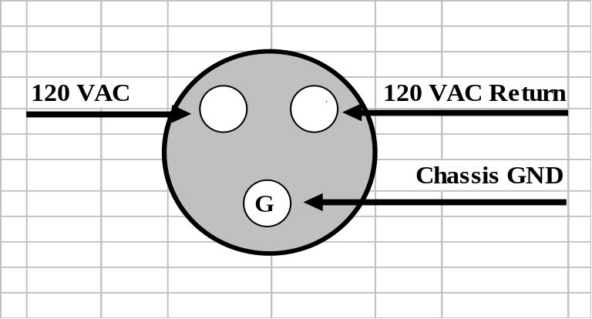

Figure 3. Auxiliary Power Receptacle Wiring Diagram

  - Device Primary Power
      - Device Primary Power Connectors

Each Presentation Device will provide a MS3470W14-4P, or commercial equivalent, primary power connector that will support the 240 VAC common power cable configuration (Figure 6). The connector will be wired in accordance with Figure 4 below.

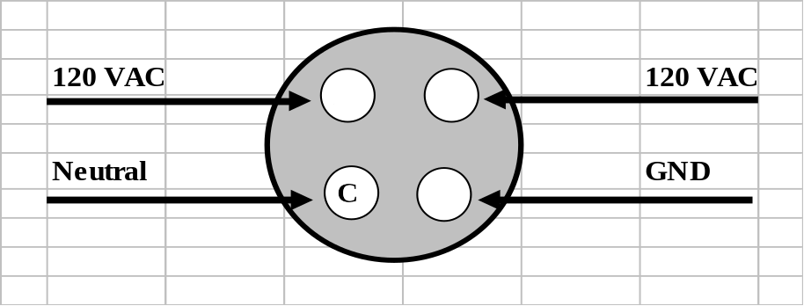

Figure 4. Target Presentation Device Primary Power 240 VAC Connector Wiring Diagram

Each other FASIT device will provide a MS3470W14-4PW, or commercial equivalent, primary power connector that will support the 120 VAC common power cable configuration (Figure 7). The connector will be wired in accordance with Figure 5 below.

A

B
C

120 VAC

120 VAC Return

Chassis GND

D

Figure 5. Device Primary Power 120 VAC Connector Wiring Diagram

      - Primary Power Cabling

In order to minimize the number of different power cables that the range must support, two cable designs are defined: one for the Target Presentation Device (PD) and one for all other devices.

The 240 VAC primary power cable to the PD will consist of (four) 4 conductors, 12 American Wire Gauge (AWG), polyethylene-jacketed cable, wired in accordance with Figure 6 below. If the PD uses 120 VAC power, only one leg of the 240 VAC is used for PD power. In this configuration, the other leg may be used to power a thermal device that may be attached to the PD. If the PD uses 240 VAC, either 120 VAC leg can power the thermal device. The connectors used are a NEMA L14-20P twist-lock and a MS3476W14-4S, or commercial equivalent.

NEMA L14-20P
Target Emplacement Plug

GND
Neutral
120 VAC
X

Y

W

G
A

B

C

D
120 VAC
MS3476W14-4S
To the PD
Figure 6. 240 VAC Common Power Cable Wiring

For devices other than the PD, a common 120 VAC power cable is required. This cable will consist of three (3) conductors, 12 American Wire Gauge (AWG), polyethylene-jacketed cable, wired in accordance with Figure 7. The connectors used are a NEMA L5-20P twist-lock and a MS3476W14-4SW, or commercial equivalent

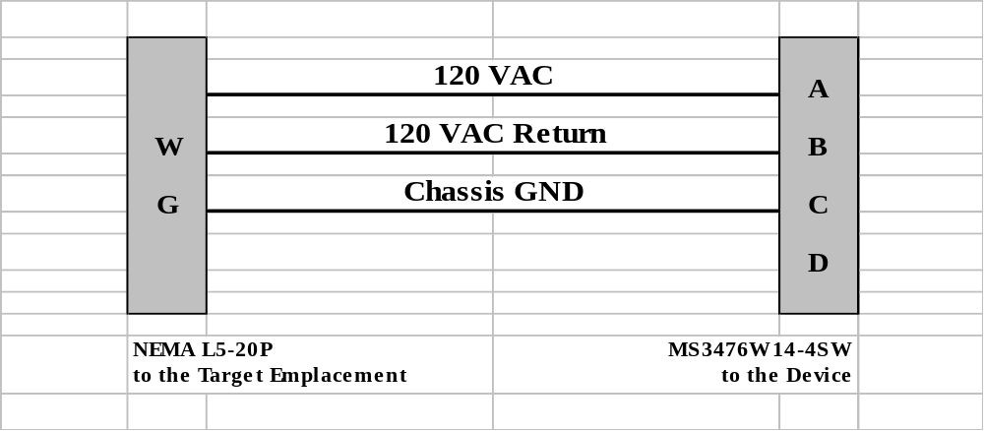
Figure 7. 120 VAC Common Power Cable Wiring

    - Device Secondary Power
Device secondary input power will be 12VDC.
      - Device Secondary Power Connector

Each FASIT device equipped for secondary input power, will provide a MS3102E22-8P, or commercial equivalent, connector that will support the common secondary power cable configuration. The connector will be wired in accordance with Figure 8 below.

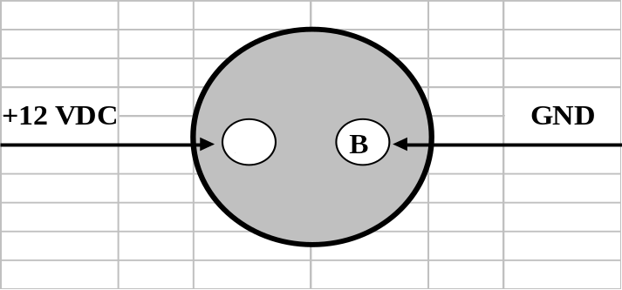
Figure 8. Device Secondary Power +12 VDC Connector Wiring Diagram
      - Secondary Power Cabling

In order to minimize the number of different power cables that the range must support, a common +12 Volts Direct Current (VDC) power cable is required. This cable will consist of two (2) conductors, 12 AWG; polyethylene-jacketed cable, wired in accordance with Figure 9 below. The connector used is a MS3106E22-8S, or commercial equivalent.

A

B

+12 VDC
GND
This end of the cable is undefined because of the various possible supply sources.

MS3106E22-8S
To the Device
Figure 9. +12 VDC Common Power Cable Wiring

  - Communication
    - Target Emplacement Communication Connector
Connection between the Target Controller and FASIT Device for data communication is accomplished using a network methodology. The target emplacement shall be equipped with a female RJ-45 Amphenol RJF21G Field data connector and associated RJFC2G receptacle cover, or equivalent. This will be wired in accordance with ANSI/TIA/EIA-568B standard as shown in Figure 10.

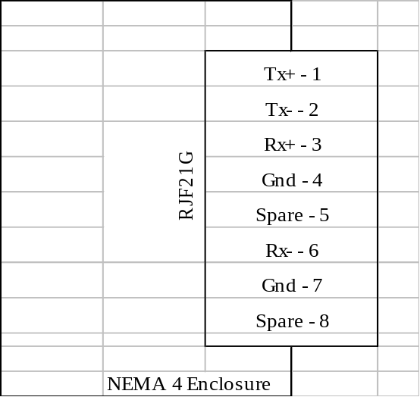

Figure 10. Target Emplacement Communication Connector

    - Device Communication Connector
The FASIT Device shall be equipped with a female RJ-45 Amphenol RJF21G Field data connector and associated RJFC2G receptacle cover, or equivalent. This will be wired in accordance with ANSI/TIA/EIA-568B standard as shown in Figure 11.

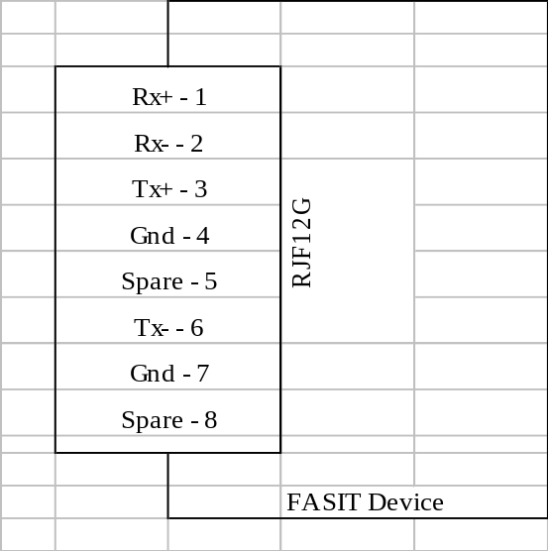

Figure 11. FASIT Device Communication Connector
A given device may be designed with another connector depending on device specification and/or contractual requirements. In this case, the device will be equipped with a jumper or “pig-tail” cable with a connector mating to the device on one end and having a female RJ-45 Amphenol RJF2PE1G Field data connector and associated RJFC2G receptacle cover, or equivalent, on the other end. The jumper cable should be 10 inches to 12 inches in length or as specified in the device contract.

    - Communication Cabling
A network type cable with a male RJ-45, Amphenol RJF6G and associated RJFC6G plug cap, or equivalent, on each end will connect the FASIT Device to the target emplacement. The cabling required for communication between the emplacement data receptacle and the FASIT Device is a Category 6 (CAT6), 24 American Wire Gauge (AWG) stranded, braided shield, Ultraviolet (UV) resistant cable. This cable will be wired in accordance with ANSI/TIA/EIA-568B standard as shown in Figure 12 below.

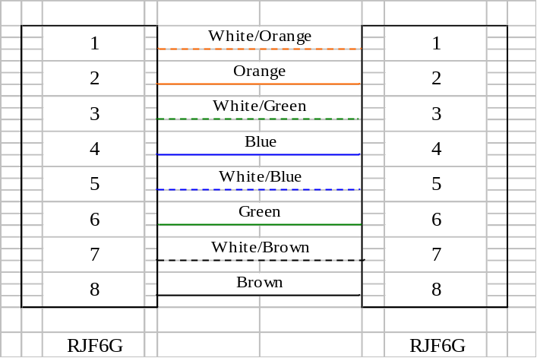

Figure 12. Target Controller to FASIT Device Communication Cable
  - Communication Electrical Characteristics
    - Network Structure and Message Protocol
Characteristics of the communication link are specified by IEEE 802.3-2002, “Carrier Sense Multiple Access with Collision Detection (CSMA/CD) Access Method and Physical Layer Specifications”. Figure 13 shows the communication link to the Target Controller.

DHCP Server/
Target Controller

TCP/IP

FASIT
Device

Figure 13. Device Communication Configuration

This document specifies the data representations, data types, and common messages to be used in two-way communication between the Target Controller and the FASIT Device at the application layer. The session layer will have full duplex communication. Individual device-unique commands and responses are delineated in the separate device ICDs. All messages defined in this and the device ICDs shall be transmitted using Transmission Control Protocol (TCP) / Internet Protocol (IP) as defined in IETF RFC-793 and IETF RFC-791. IPv4 may be used with a planned upgrade path to IPv6.

The FASIT Device IP address shall be assigned dynamically by a Dynamic Host Configuration Protocol (DHCP) server. The Target Controller host IP address shall be statically assigned to 192.168.1.1. (An IPv6 static address will be provided once determined.) The Target Controller software shall listen for and accept incoming connections on port 4000. The FASIT Device shall connect to the Target Controller Component. Once a connection is established, the Target Controller software shall transmit a Device Definition Request command (message number 100, defined below) to the Device and in response, the Device shall transmit a Device ID and Capabilities message in accordance with the device-type ICD to inform the Target Controller of its device type, MAC address and device-specific capabilities. When communication with the Device is no longer required, the Target Controller shall close the connection to the Device.

In the event of the TCP/IP connection between the Device and Target Controller being severed (e.g. closed by Device or Target Controller link failure), the Device is responsible for reconnecting to the Target Controller. In the event of failure to establish a TCP/IP connection to the Target Controller, the Device shall periodically reattempt to connect at an interval not exceeding 30 seconds between attempts.

Note: Device MAC addresses can be dynamically retrieved by Device query to the Network Interface Card (NIC) or stored in Device firmware.

    - Representation of Data
Byte ordering, enumerated type representation, and numeric type representation are described in paragraphs 3.3.2.1 through 3.3.2.4.

      - Byte Ordering
The order of transmission of data described in this ICD shall be resolved to the byte level. All data shall be transmitted in Big-Endian byte order. Figure 14 illustrates the order of transmission. Bits are numbered across the top of the figure. Bytes are transmitted in the order in which they are numbered.

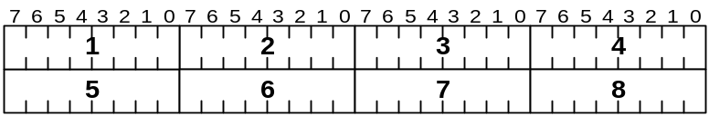

Figure 14. Byte Transmission Order
Whenever a byte represents a numeric quantity, the left-most bit in the diagram shall represent the high-order or most significant bit. That is, the bit labeled 7 is the most significant bit in each byte in Figure 14. Similarly, whenever a multi-byte field represents a numeric quantity, the left-most byte in the diagram shall represent the high-order or Most Significant Byte (MSB).

      - Enumerated Type Representation
All enumerated types shall begin with zero for the first element of the enumeration. Enumerated types shall be one to four bytes in length.

      - Numeric Type Representation
All numeric types shall be represented as integers or floating-point numbers.
- Integers shall be signed or unsigned. Signed integers shall be represented in twos-complement form, where the most significant bit shall be the sign bit. The sign bit shall have a value of zero for positive numbers and 1 for negative numbers. Integers shall be one to four bytes in length.
- Floating point data types, both single- and double-precision, shall be represented as specified by IEEE STD 754-1985.
- Character data types shall be 8-bit signed quantities.
- Boolean data types shall be 8-bit quantities where zero is a false value, and all other values are true.

Table 1 shows the designations for these numeric types, as called out in the message descriptions in this and the device-type ICDs, as well as the bit length and range of values for each.

Table I. Variable Detail

Variable Type | Length (Bits) | Range of Values
Short integer | 16 | -32,768 to +32,767
Unsigned short | 16 | 0 to +65,535
Long integer | 32 | -2,147,483,648 to +2,147,483,647
Unsigned integer | 32 | 0 to +4,294,967,295
Float | 32 | 1.18 E -38 to 3.40 E +38
Char | 8 | -127 to +127
Unsigned char | 8 | 0 to +255
Boolean | 8 | All zeros = False,  All other values = True

      - Bit Fields
Bit fields of specified lengths are used to define device capabilities and OEM fault fields for some devices. In each case, a 1 in the bit position shown indicates the specified capability or fault indication.

    - Target Controller to Device Common Message
The Device Definition Request message, shown in Table II, is sent from the Target Controller to inform the Device to send a Device ID and Capabilities message. The Device Definition Request message is common to all device types (PD, RED, RD, and ESD). When a new connection is received by the Target Controller, a Device Definition Request message will be sent to the device. Devices receiving this message will send the Device ID and Capabilities message that is specific to its device type. This will serve to inform the Target Controller what type of device it is communicating with. The Device Definition Request consists of a standard message header with a message number of 100.

Table II. Message Number 100 – Device Definition Request
Field Size | Message fields
Bits  0 – 127 | Message Header | Message Number – Unsigned short
Bits  0 – 127 | Message Header | ICD Version Number – 2 Unsigned shorts
Bits  0 – 127 | Message Header | Sequence ID – Unsigned integer
Bits  0 – 127 | Message Header | Reserved For Future Use - 32 bits, all zeros
Bits  0 – 127 | Message Header | Length of Message – Unsigned short

Table III below contains detailed message field information for the header.

Table III. Message Header
 | Variable Type | Definition | Comments
1 | Unsigned short | Message Number | This will be a fixed number so that the Device knows exactly what the message will contain.
2 | 2 Unsigned shorts | ICD Version Number | This field contains the release designation of the ICD that the sending device software/firmware was written against (e.g. 1.0 or 2.3). The first unsigned short will represent the whole number portion of the revision designation and the second unsigned short will indicate the fractional portion of the revision designation. The decimal point will not be included.
3 | Unsigned integer | Sequence ID | This ID will be a unique number that the Target Controller or Device will assign to this field, depending on which side sent the message. The Target Controller and Device shall each maintain their own sequence ID value which they shall increment and place into this field for each message sent.
4 | Unsigned integer | Reserved for future use. | This field is reserved for future use and shall be set to all zeros.
5 | Unsigned short | Length of Message | This will inform the Device or Target Controller how many bytes are contained in the message. Length includes message header and body.

    - FASIT Device Messaging Response
The Command messages and coordinating responses are shown in Figures 15 through 18 below. These message sequences are in no particular order and occur when the Target Controller needs to obtain Device information or instruct the Device to perform one of its functions. Messages from the Target Controller and Device could be transmitted at any time. There are no limitations with regards to response time and message sequencing. Message correlation will be given through the sequence ID within the message header. This drawing makes no reference as to how this is accomplished inside the Target Controller or the Device.

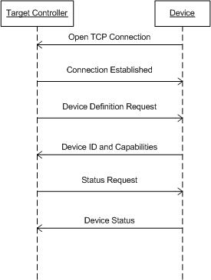

Figure 15. Device Connection
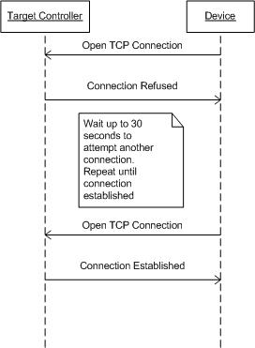
Figure 16. Device Reconnect

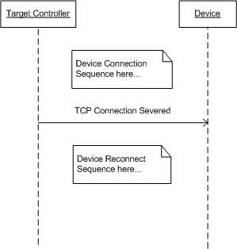

Figure 17. Device Connection Severed

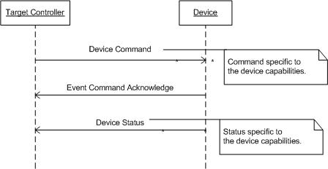

Figure 18. Device Command
- Glossary of Applicable Terms
Name | Description
Battle Effects | Battlefield effects, apart from the target acquisition and weapon effects, employed to enhance the realism of the battlefield.
Built-In Test (BIT) | Designing software to include self-testing or built-in-testing code as a powerful way to improve the testing process. Built-in-testing techniques are based on the concept of contracts within a program, where data values and program states must be checked before the program can continue execution. The most common built-in-testing tool is the assertion, which is an evaluation of a Boolean statement expressing some correct state in the program. If the statement evaluates to false, the assertion causes the program to take some specified action, generally aborting program execution. Assertions are the basis of four basic built-in-testing tools that are generally used to enforce software requirements: precondition validation, post condition validation, and invariant checking and data assertions.
Built-In Test Equipment (BITE) | The hardware or software facilities integrated into a system, equipment, replaceable item or module to monitor functions and check out serviceability.
Common Training Instrumentation Architecture (CTIA) | The CTIA is the architecture core of the Live Training Transformation Strategy. CTIA is the technical architecture that provides commonality across training instrumentation systems and interoperability across live, virtual, and constructive training systems. It consists of standards and protocols to be used by system developers and the core software component of training instrumentation systems.
Combat Training Center (CTC) | An Army program established to provide realistic joint service and combined arms training in accordance with Army doctrine. It is designed to provide training units opportunities to increase collective proficiency on the most realistic battlefield available during peacetime. The four components of the CTC Program are:  •The National Training Center  •The Combat Maneuver Training Center  •The Joint Readiness Training Center  •The Battle Command Training Program
Communications Subsystem | The capabilities required to exchange data, messages, and other target-related information among the components that comprise the targetry system.
Component | This refers to an individual item that is a member of the FASIT physical architecture.
Configuration | Current setting of the variable parameters of hardware/software.
Configuration Parameters | Specific settings for configuring the capabilities of the targetry system for a training event.
Continuous Built-In Test (C-BIT) | Built-In Test software designed to monitor the operational readiness of the unit continuously and report any detected failures or reduced capabilities.
Engagement Scoring Device  (ESD) | A device to detect the interaction of the weapon systems at the target. This device will provide information on these interactions to include: hit location on the target, miss distance if within a user defined reference grid, and the identity of the weapon mechanism interacting with a target.
External Interface | An external interface is the physical and electrical characteristics, and also the communication characteristic to a device that is external to the component.
Feedback | Return of data about the result of a process.
Field Training Exercise (FTX) | Exercise conducted under simulated combat conditions in the field. FTXs fully integrate the total force in a realistic combat environment. They involve combat arms, Combat Support (CS), and Combat Service Support (CSS) units. FTXs encompass such training as battle drills, crew drills, and Situational Training Exercises (STXs) to reinforce soldier and collective training integration. They are used to train the commander, staff, subordinate units, and slice elements.
Initiated Built-In Test (I-BIT) | Initiated Built In Test can occur when the device is powered-on or is issued a command from an external device to perform BIT.
Live-Fire Exercise (LFX) | Exercise that is resource-intensive; player units maneuver and employ organic and supporting weapons systems using full-service ammunition. LFXs integrate all combat arms, CS, and CSS elements. The extensive range and resource requirements usually limit them to platoon and company team levels. Consequently, their principal focus is unit and weapons integration at company team level. LFXs provide realistic training on collective and soldier skills.
Live Training | Training executed in field conditions using tactical equipment, enhanced by Training Aids, Devices, Simulators, and Simulations (TADSS) and Tactical Engagement Simulation (TES) to simulate combat conditions.
Live Training Environment | Live training uses go-to-war systems and synthetic training systems, on real terrain, operating in the full range of actual battlefield day/night/adverse weather environmental conditions. During live training events, units deploy against an OPFOR and use actual or simulated systems and weapons equipped with tactical engagement simulators to replicate combat weapons effects and battle damage.
Logical Range Configuration | A range configuration that exists in the controller’s software, which consist of logical targets whose behaviors and reactions can each be configured as single entities on the range.
Logical Target | A logical target is a collection of devices (Representation Devices, Presentation Devices, Battlefield Effects Devices, Weapons Effect Measurement Devices, and/or Legacy Enhanced Remoted Target System (ERETS) Components) allocated for control by a Target Controller.
Logical Target Behaviors | These will consist of time-sequenced executions of the functions associated with the devices allocated to the given logical target.
Logical Target Reactions | These will consist of time-sequenced executions of the functions associated with the devices allocated to the given logical target executed as a reaction to a CTIA event, Hit/Miss detection, or similar event.
Maintainability | The ability of a system to be retained in or restored to a specified operational status within a given period of time, when the maintenance is performed in accordance with prescribed procedures and resources.
Mission | (1) (DOD) 1. The task, together with the purpose, that clearly indicates the action to be taken and the reason therefore. 2. In common usage, especially when applied to lower military units, a duty assigned to an individual or unit; a task. 3. The dispatching of one or more aircraft to accomplish one particular task. (2) (FM 25-100) The primary task assigned to an individual, unit, or force. It usually contains the elements of who, what, when, where, and the reasons therefore, but seldom specifies how.
Operational Architecture  (OA) | An operational architecture establishes the basic framework and structure for what is to be built. An Operational Architecture defines the field deployment of the system components to the force by echelon, unit type, equipment, and information exchange requirements. Operational architecture (OA) contains text, graphic models to show functions and information, graphics representations of how the Army organizes and equips to execute C4 processes, and a data base to provide detailed characteristics about information exchanges, such as format (voice/data/imagery), speed of service, perishability, and criticality. The OA will show relationships among organizations and functions in terms of the information they need, use, and exchange. It also addresses the platforms and equipment that are to be available, as well as the methodology to upgrade and interoperate with platforms containing embedded processors.
Opposing Force Materiel (OPFOR) | The Live Capstone Requirements Document (CRD) defines OPFOR as a family of equipment supporting six architectural elements: OPFOR armor, OPFOR fire support, OPFOR aviation, OPFOR air defense, OPFOR engineer, and OPFOR radio electronic.
Physical Range | The actual configuration, including type (Target Presentation, Target Representation, BES), location, and control, of individual devices available on a range.
Plug-N-Play | The capabilities of the system to automatically recognize, control, and communicate with system peripherals (e.g. targetry, Battlefield Effects Devices (BED), audio/video collection device).
Power-On Self Test (POST) | Power-On Self Test is software designed to perform operational readiness of the device when it is initially powered on.
Presentation Device | The presentation devices are the electro-mechanical units that actually expose, conceal, or change the aspect the target representations.
Range Effects | The ability to simulate weapon effects on targets for casualty and damage assessment, simulate shoot-back target signatures and sounds associated with tactical threat engagements, as well as general battlefield effects that will provide a realistic training environment.
Range Effects Device  (RED) | The device that provides the ability to simulate weapon effects of targets for casualty and damage assessment, simulate shoot-back target signatures of tactical threat engagements, as well as general battlefield effects that will provide a realistic training environment. Examples include pyrotechnic, illumination, audio, and smoke devices.
Record | Collect, process, and store data in non-volatile memory.
Reliability | The ability of a system to perform its required functions with correct and consistent results over a period of time.
Safety | To ensure the system is safe to operate and maintain and will not present uncontrolled safety hazards throughout the life cycle of a system.
Situational Training Exercise (STX) | A short, scenario-driven, mission-oriented, limited exercise designed to train one collective task, or a group of related tasks or battle drills, through practice.
Speed of Service | The time between the first bit of a message packet to leave a source node on a network to the last bit of a message packet received on a destination node on a network.
Standard | (DOD, NATO) An exact value, a physical entity, or an abstract concept, established and defined by authority, custom, or common consent to serve as a reference, model, or rule in measuring quantities or qualities, establishing practices or procedures, or evaluating results. A fixed quantity or quality.
Status | Current operational condition.
Supportability | That characteristic of a system and its support system design that provides for sustained system performance, at a required readiness level, when supported in accordance with specified concepts and procedures.
System Architecture | System architecture is the technical companion document to the Operational Architecture. It establishes the specific hardware needed to provide the connectivity required in the Operational Architecture. The System Architecture is a description of the physical connectivity of an information system which includes: identification of all equipment and their physical deployment; the specification of such parameters as the bandwidth required on each circuit; and the description-including graphics-of technical characteristics and interconnection of all parts of an information system. The system architecture can be developed for an individual system or at higher levels to depict the integration of numerous systems in to a system of systems architecture.
Target Controller | Control and sequence processes for the logical target.
Targetry | The family of hardware/software components that are integrated as a single system that provides the targets, target behaviors, and control required to support a live training event.
Targetry Command | The capability to instruct and direct assigned assets to perform specific targetry actions, tasks, and operations to achieve a desired end state, outcome, or mission associated with a live training event.
Targetry Command and Control | An interactive process that integrates, organizes, and synchronizes all parts of the targetry system to accomplish common objectives, tasks, operations, and missions associated with a live training event.
Targetry Control | The capability to monitor, analyze, and confirm the appropriate, specified ("commanded") targetry actions, tasks, and operations associated with a live training event are performed and the effects that result from these actions, tasks, and operations ("feedback").
Targetry Feedback | The capability to present FASIT data in support of the preparation of the targetry system for and the execution of a training event, and integrating the targetry system data into post training feedback for both targetry and training assessment purposes.
Targetry System | The tailored set of assets comprised of SW, HW, communications, procedures and personnel that act as a single functioning unit (system-of-systems) to direct and perform the targetry actions, tasks, and missions required to support a live training event.
Technical Architecture | A technical architecture is a minimal set of rules governing the arrangement, interaction, and interdependence of the parts of an information system. The purpose of the Technical Architecture is to ensure that a conformant system satisfies a specific set of requirements. A technical architecture is comparable to a building code, not telling you what to build (i.e., the operational architecture) nor how to build (i.e., the systems architecture), but rather delineating the standards to which to build to pass inspection. The technical architecture identifies a framework of standards and includes top-level systems specifications, and architectural diagrams for technical interface specifications.
Technical Performance Measure (TPM) | That capability or characteristic that is critical to the system meeting its operational objective.
Weapon Effects | The detectable simulated signatures of a battlefield participant caused by a successful engagement of an associated FASIT target.

